The case for prudent financial liberalisation and its policy implications

Paper prepared for Berlin 'Finance and Development’ Conference, Dec 11, 2013.
Organised by AFD-BMZ-EUDN.

Professor Stephany Griffith-Jones
Financial Markets Director, Initiative for Policy Dialogue, Columbia University
sgj2108@columbia.edu
www.stephanygj.net
Twitter: @stephanygj
www.policydialogue.org

I Introduction
The international community sees sustained and inclusive growth as its main economic aim. At a national level, governments are broadly committed to the same goal. Additionally, in a globalized world economy, countries and enterprises need to be internationally competitive to sustain such growth.
A well-functioning financial sector, both national and international, needs to play important roles to achieve these aims. Indeed finance has been compared to the blood circulating in the body, enabling it to live and function well.
To achieve this key positive role, the financial sector needs to encourage and mobilise savings (for example by protecting the safety of savings), intermediate these savings at low cost, ensure savings are channelled into efficient investment, as well as helping manage the risks for individuals and enterprises. Because the financial sector has such important effects throughout the economy it also needs to adhere to a key principle of the Hippocratic oath that medical doctors swear to, which is to do no harm to the rest of the economy. Therefore there should be as few and as small crises that stem from the financial sector, as these have huge costs, both fiscal and on growth, employment and investment.
It could be argued that the financial sector performed these functions relatively well both in developing and developed countries in the post -World War II period. Domestic financial sectors were relatively small and fairly tightly regulated, partly because after the Great Depression a number of regulatory measures were applied, including the Glass- Steagall Act that separated investment and commercial banking as well as the existence of requirements for liquidity. At the same time, capital accounts were relatively closed, especially in developing countries. Developed countries liberalized their capital accounts, but most did so very slowly (Griffith-Jones et al, 2003).
However, from a policy perspective there were concerns that “financially repressed” systems, as they were then called, did not deliver sufficient finance to important sectors at low enough cost and at long enough maturity. From a more theoretical perspective, the idea that financial markets were efficient encouraged financial liberalization, with light or no regulation. This covered both domestic and external liberalization. Latin America was a first mover on liberalization in the late seventies, especially in the Southern Cone. This process was followed by frequent and costly crises, including the major Latin American debt crisis, which led to the “lost decade” in terms of growth and development. Diaz Alejandro (1985) already then perceptively synthetized this as: “Good-bye financial repression, hello financial crisis.” Increasingly frequent crises in different parts of the developing and emerging world followed, including the East Asian crisis which involved some of the most successful developing countries. The idea that these crises were transitory problems, which would be overcome once these financial markets matured and deepened (and became more like those of the developed countries, especially the US and the UK one) was profoundly challenged when such a major crisis hit the developed countries, starting in 2007 in the US, which had the most liquid and deepest financial market in the world.
Furthermore, increased sustainable access to credit at low cost did not seem to improve as expected as a result of financial liberalization, especially for SMEs and for long term investment (e.g. in infrastructure). Indeed, during and after crises, credit channels became blocked, especially for long-term credit to the private sector. The pro-cyclical nature of domestic finance, as well as of capital flows, became extremely evident.
An early insight on why liberalized financial markets can be particularly damaging and much more so than the liberalization of other markets, comes from Stiglitz (1994) who argues that market failures in financial markets are likely to be endemic as those markets are particularly information intensive, thus making information imperfections and asymmetries as well as incomplete contracts (Stiglitz and Weiss, 1981) more important and disruptive than in other economic sectors. Therefore in important parts of financial markets, market failures tend to be greater than government failures. In such cases government interventions are more desirable than in other sectors (for example via regulation of domestic financial markets and banks, as well as management of the capital account) if their benefits outweigh their costs.
This approach to finance is consistent with far freer markets in the rest of the economy, in sectors where markets are more efficient than governments. Indeed, it can be argued that the prevalence of market failures in financial and banking markets makes sufficient regulation a key pre-condition for the successful operation of the market in the rest of the economy. The link with the real economy is clearly put by Mishkin (1996), who writes that a ”financial crisis is a non-linear disruption to financial markets in which adverse selection and moral hazard problems become much worse, so that financial markets are unable to efficiently channel funds to those who have the most productive efficient opportunities.”
A key market imperfection in the operation of financial markets, basically across the board, is the tendency to “boom-bust”, thoroughly analysed in historical terms in the book by Reinhart and Rogoff (2011). Building on the theoretical tradition of Marshall (1923), Keynes (1936) and Minsky (1977), Kindleberger (1978) had earlier developed an approach which considers financial crises as a response to previous excesses. Such excesses seem clearly far greater in financial and banking markets that are more liberalized and not properly regulated. An interesting recent insight on private capital flows is provided by the IMF (2011) which gives evidence that financial market volatility has increased over time and has spread to transactions and flows which are generally considered to be less volatile (such as foreign direct investment).
In the case of “booms and busts” of capital flows to developing and emerging economies, this was first seen in the post- World War II era in a major way in Latin America , starting in the late 1970s and ending in the major debt crisis of the 1980s, called the “lost decade” to development. This pattern was characterized by Ffrench-Davis and Griffith-Jones (1994) as surges and reversals of capital flows; more famously the reversals were called “sudden stops” by Guillermo Calvo and associates. In an important paper Calvo, Leiderman and Reinhart (1993) showed that an important part of the surge was being caused by factors external to the region, especially the US interest rate. Calvo (2013) later described how this paper and its’ main conclusions were challenged particularly at the IMF, who then attributed such flows only or mainly to “good fundamentals” in the countries, and did not contemplate the role of global capital markets and their imperfections in the origin of major capital flows surges and reversals. The IMF has, however, increasingly accepted the role of international capital market imperfections in generating boom-bust cycles of capital flows and has begun - especially more recently - to draw important policy implications from this experience, as discussed below.
As Devlin, French-Davis and Griffith-Jones (1994) argued, an important part of the explanation of both the surges, and the subsequent reversals, were due to intrinsic features on the “supply side” of capital flows. This included institutional features, such as very short term incentives to key actors, such as internationally active pension and mutual funds as well as investment bankers, that contributed to herding behaviour (for more detailed analysis see Griffith-Jones, 1998). There were - and still are - many such institutional features which contribute to this pattern of capital flows, such as the pro-cyclical methodologies and behaviour of rating agencies (see Reisen, 2003; Goodhart, 2010).
It is interesting that there is a recent econometric literature showing that financial crises are often preceded by booms of capital flows (for example Agosin and Huaita, 2012 and Borio, 2012). In the case of Latin America, net capital flows during the pre- 1980’s debt crisis years (1977-1981) reached 4.5% of GDP annually (Ffrench-Davis and Griffith-Jones, op cit.). It is important to stress a somewhat neglected fact that capital flows (in this case mainly intra-European ones) have played a major role in the origins of the recent European sovereign debt crisis. Indeed, it is not often emphasized that in Europe capital flows were numerically larger than in Latin America. Thus, in Greece, the cumulated capital flows grew from around 30% of GDP in early 2002 to around 80% of GDP in early 2008 (almost 10% of capital flows as proportion of GDP annually). In Spain this stock grew from just over 20% of GDP in early 2002 to 60% mid 2008, around 7% of capital flows as proportion of GDP annually, with similar increases reported for Portugal (Pisani-Ferry and Merler, 2012, based on Eurostat data).
From this comparison, it can be seen that capital flows were on average higher to the periphery European countries during the 2002-2008 years then they were to Latin America in the 1977-1981 pre-debt crises years. These massive capital flows were accompanied in Europe, as they had been previously in Latin America, by very low spreads as lenders and investors massively under-estimated risk. As crises started in both cases, spreads either shot up, often to unsustainable levels, or credit rationing occurred so that countries became unable to raise new funds or loans.
In section 2 we will examine the policy issues around domestic financial sectors (their size and structure) as well as that of their regulation. Section 3 will examine the policy issues of capital account management, building on the analysis of this introduction. Our analysis will be framed by the two aims of the financial sector: to fund in an efficient and sustainable way the needs of companies and households (thus supporting inclusive growth) and to avoid damaging crises by supporting financial stability. This analysis will be done in a context where we have been brutally reminded that financial and banking markets in developing, emerging and developed countries are riddled with imperfections and are prone to boom bust cycles. Though reference will be made to developed economies, we will focus here more on developing and emerging economies.
2. The domestic financial sector
As regards the domestic financial sector, we will base our analysis more on issues from the perspective of low income countries (LICs) but drawing on lessons from emerging and developed economies. The financial sector and its regulation is a particularly challenging and important field for policy- makers in LICs, in the pursuit of both inclusive growth and financial stability, for two reasons.
Firstly, LICS face the traditional challenge of expanding access to the financial sector to large parts of the population and important segments of enterprises that have been excluded from it. Furthermore, where access is available, it is often too short-term and very costly. These features are an important obstacle for growth. Overall, financial sectors in low income African countries are still relatively shallow. Based on World Bank data, the average credit to GDP ratio in 2010 for Sub Saharan African LICs was below 20%, though higher in some countries (see Griffith-Jones with Karwowski, 2013). It is interesting that Sub-Saharan (SSA) LICs have a lower credit to GDP ratio than non-SSA ones (see, for example Beck, 2013). Furthermore, according to World Bank surveys, only 17% of small enterprises in SSA have access to credit, the lowest among all developing country regions, with for example 41% of small enterprises in Latin America and the Caribbean reporting access to credit. Indeed, 48% of small enterprises in Sub-Saharan Africa report that lack of access to credit is a major constraint for their investment, with 41% of even medium enterprises in SSA saying that lack of credit hinders their investment.
Another important issue is the cost of credit, especially for SMEs. In countries like Ghana, reportedly the cost of SME lending, and especially the spreads banks charge, has hardly come down in the last two decades, even though the number of banks has increased significantly which should have increased competition and lowered spreads. This puzzle requires further research, including on policy measures to be taken which could be effective to change that.
Secondly, internationally there is a rethinking of the scale and structure of a desirable financial sector and a major reform of its regulation in light of the major financial crisis that started in 2007/8. An increasingly accepted perception has arisen that banking and financial markets have deep seated imperfections. There is a large literature on the reform of financial regulation, especially in developed and emerging economies (see for example, Griffith- Jones, Ocampo and Stiglitz, 2010, as well as IMF, 2012) with Haldane and Madouros (2012) emphasizing the need to simplify regulation in developed countries, the latter resonating very well with LICs. Three well-known commissions also analyzed the sources of the crisis and the need for new policy responses. See the reports of the Larosière Commission (2009), the Stiglitz Commission (United Nations, 2009) and the Warwick Commission (2009). National reviews, such as the UK Turner Review, also provided very insightful analysis. A great deal of work has been done by international regulatory bodies, such as the Basle Banking Committee and the Financial Stability Board, which have become G-20 bodies since the global financial crisis. This expansion was very welcome, but where there is no representation in them of smaller and especially poorer economies.
There is a need to understand the implications of the analytical rethinking, and major regulatory changes being agreed, for low income countries’ financial sectors and their regulation. As the Governor of the Central Bank of Ghana Henry Wampah (2013) eloquently puts it, the financial sector is a “double-edged sword”, with potentially very large positive effects for inclusive growth, but also - if not robustly regulated - very large risks, “because the absence of this [regulation] could have disastrous outcomes as observed during the recent global financial and economic crises.”
Because financial sectors for SSA LIC countries are still at an early stage of development, lessons from the global financial crisis as well as of previous emerging economies’ crises, could inform their financial sector development strategies as well as their financial regulation. The advantage of being a latecomer to financial development is that African LICs can learn both positive and negative lessons from financial development and crises in other regions.
LICs financial sectors, while generally still shallow, are experiencing in some countries fairly rapid growth. This growth is often concentrated in credit to real estate or households more generally (see for example, Griffith-Jones with Karwowski, op cit.). Combined with African countries’ vulnerabilities, such as to external shocks, this might pose risks to financial system stability in the future. Whilst it is very positive that in the last ten years in Sub-Saharan Africa there has been only one major banking crisis (in Nigeria) - a country that had seen a very rapid increase in the ratio of credit to GDP from 11% in 2000 to 30% in 2010 - care must be taken that such a positive record does not generate complacency that financial stability is ensured as has occurred so frequently in most other regions of the world. One important area for financial regulation, in LICs as elsewhere, is therefore for financial regulation to be counter-cyclical, that is to lean against the wind, when credit increases at too fast a pace for SSA (Bagyenda, J., Brownbridge, M. and Kasekende, L., 2011, also see Griffith-Jones and Ocampo, 2010, more generally). Important analytical research is beginning in Sub-Saharan Africa itself, on how such counter-cyclical or macro-prudential regulation should be implemented in LICS (see Kharkar, 2012, writing for Bank of Uganda Financial Stability Report).
One positive advantage of regulation in several African countries may be that they have developed a different approach, which seems better suited to African realities than internationally adopted regulation rules that are extremely complex. Bagyenda, J., Brownbridge, M. and Kasekende, L. op cit., analyse this approach, which includes limiting the amount banks can lend to individual borrowers and encourages banks to have a structure of assets that are less risky rather than relying on extremely complex models to try to measure risk, partly because data is not available for such models for a sufficient period of time. A challenge for LIC regulators is how to combine these and other existing elements of their existing regulations with the suggestions and rules coming from the international discussion, particularly from the Basle Banking committee, and adapt them to their own realities and policy objectives.
More broadly, there are issues about the desirable size and structure of the financial sector in both low income and middle income countries. The traditional positive link between deeper as well as larger financial sector and long term growth, that started in the literature with Bagehot and Schumpeter, and was reflected in quite a large part of the empirical literature, such as Levine (2005), is being increasingly challenged. Authors like Easterly, Islam and Stiglitz (2000) had already early on suggested that financial depth (measured by private credit to GDP ratio) reduces volatility of output up to a point, but beyond that (possibly around 80-100% of GDP) actually increases output volatility. More recently, a number of papers are showing an inverse relation between the size of financial sector and growth, especially beyond a certain level of financial development. Thus, Bank for International Settlements (BIS) economists (Cecchetti and Kharroubi, 2012), based on empirical work, reach the following conclusions:
“First, with finance you can have too much of a good thing. That is, at low levels, a larger financial system goes hand in hand with higher productivity growth. But there comes a point, where more banking and more credit lower growth. Secondly, looking at the impact of growth in the financial system on real growth, clear evidence is found that faster growth in finance is bad for aggregate real growth. This implies financial booms are bad for trend growth. Hence, macro prudential or counter-cyclical regulation is important.”
Along similar lines, an IMF Discussion Paper (Arcand, Berkes and Panissa, 2012) suggests empirical explanations for the fact that large financial sectors may have negative effects on economic growth. It gives two possible reasons. The first has to do with increased probability of large economic crashes (Minsky, 1974, Kindleberger, 1978 and Rajan, 2005) and the second relates to potential misallocation of resources, even in good times (Tobin, 1984). De la Torre et al. (2011) point out that "Too much finance" may be consistent with positive but decreasing returns of financial depth which, at some point, become smaller than the cost of instability. It is interesting that the IMF Discussion paper (op cit.) results are robust to restricting the analysis to tranquil periods. This suggests that volatility and banking crises are only part of the story. The explanation for the "Too Much Finance" result is not only due to financial crises and volatility, but also misallocation of resources.
It is also likely that the relationship between financial depth and economic growth depends on whether lending is used to finance investment in productive assets or to feed speculative bubbles. Not only where credit serves to feed speculative bubbles but also where it is used for consumption purposes, as opposed to productive investment, the effect of financial depth on economic growth seems limited. Using data for the period 1994-2005, Beck et al. (2012) and Beck et al. (2011) show that enterprise credit is positively associated with economic growth but that there is no correlation between growth and household credit. Given that the share of bank lending to households increases with economic and financial development, and household credit is often used for consumption purposes whereas enterprise credit is used for productive investment, the allocation of resources goes some way towards explaining the non-linear finance-growth relationship. In African countries, only a small share of bank lending goes to households; however as financial sectors and economies grow, this will change, as has been the case in South Africa and Mauritius (see below).
Crucial in the LIC context is the extent to which the findings on the relationship between the structure and size of the financial sector and growth in more developed economies are relevant for - and apply to - African LICs because their financial systems are markedly different, and above all are much smaller in absolute size and in proportion to the size of their economy. Whilst the argument and evidence that “too big” a financial sector is bad for growth may be less relevant for countries with very shallow financial sectors (and indeed policies to gradually deepen these financial sectors may be desirable), the need to avoid too rapid growth - even from relatively small levels - seems equally relevant for any economy. Furthermore (as discussed below) the importance of an appropriate structure of the financial sector, so it helps fund inclusive and sustainable growth, is also highly relevant for both low income and middle income countries.
Fast credit growth might exacerbate vulnerabilities and enhance the risk of financial crises, as it has done in most countries and regions of the world, both emerging and developed. In the African context, the case of Nigeria provides an illustration that banking crises might also cause a negative link between rapid growth of the banking sector and economic growth, even at relatively low levels of financial development (Nigeria saw a very rapid increase in the ratio of credit to GDP from a very low level, 11% in 2000 to 30% in 2010). In 2004/2005 the Central Bank of Nigeria (CBN) mandated a steep increase of minimum bank capitalisation with a view to create large internationally competitive banks and increase financial depth (Soludo, 2004). Banks achieved this capitalisation, which was high even by international standards, by means of equity investment, mergers and acquisitions, resulting in the consolidation of the banking system. The consolidation in the domestic banking sector, along with abundant capital in the wake of rising oil prices, reportedly increased the speed of credit creation with significant flows to sectors with little growth impact. This included loans used to finance share purchases, setting the stage for a financial asset bubble, particularly in bank stocks (Sanusi, 2010). The financial sector boom ended in a bust with a systemic banking crisis in 2009 as financial sector growth had not been accompanied by the corresponding regulatory and supervisory upgrade. The cost of cleaning up the balance sheets and recapitalising the banks concerned is estimated at almost 8 per cent of GDP (IMF, 2011).
Rapidly growing credit to households - even though desirable when strengthening reasonable levels of domestic demand and financial inclusion in a sustainable way - might cause financial instability if not regulated prudently. This is also the case if lending is excessively channelled into the construction sector, creating a housing bubble. The two most advanced African economies which are both upper middle income countries - South Africa and Mauritius - have recently experienced or are currently experiencing a construction boom. Both economies possess relatively deep financial markets with strong private domestic lending, including significant consumption credit extension. Figure 1 shows that private credit in high income economies was around 100% of GDP on average in 2010 while it accounted for 60-80% of GDP in Mauritius and South Africa.
Figure 1. Private Credit Extension in African Middle Income Countries Compared to High Income Countries, 1990-2000
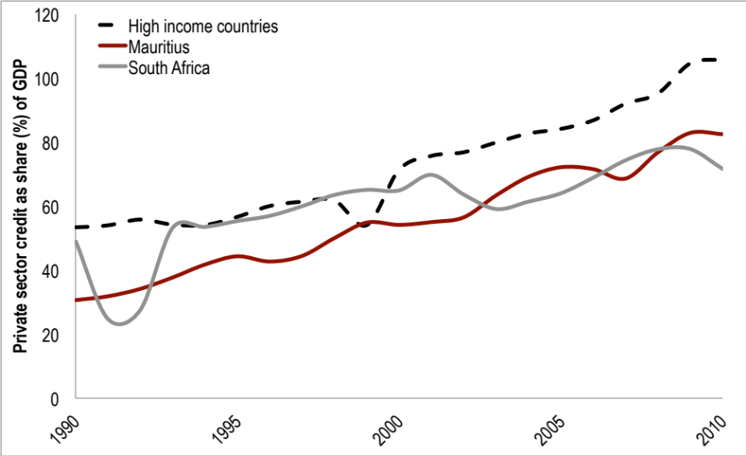
Source: Griffith-Jones with Karwoski, op cit , based on World Development Indicators, World DataBank, World Bank, 2013.
Comparing it internationally, South Africa was the country in Africa which experienced the strongest house real price gains between 2004 and 2007, by far exceeding even the price growth in the booming residential property markets of the US and the UK (see Griffith-Jones with Karwoski, op cit.). In South Africa the ratio of household to business credit is approximately 1:1. The large majority of household borrowing takes on the form of mortgage finance. During the early 2000s this led to an unprecedented housing boom in South Africa fed by growth in housing loans of over 500% in real terms between 2000 and 2010 (see Figure 2). This was largely absorbed by upper income South African households accounting for three quarters of total household credit created (DTI, 2010). In an attempt to reduce inflation, asset price increases and potential macro-economic over-heating, the South African Reserve Bank gradually initiated monetary tightening in 2006.
The subsequent economic slowdown in South Africa was to a large extent based on domestically accumulating economic and financial imbalances while the Global Financial Crisis merely intensified the recession of 2008/09. A positive aspect was that there was no financial crisis, perhaps because of the policy response from the economic authorities. However, as and if mortgage credit picks up in the future, and especially if it does at a very fast pace, care has to be taken to regulate this. The South African experience reiterates that private sector credit expansion at very high levels might lead to output volatility and adverse growth effects, as discussed in the literature above. In order to prevent future crisis and foster economic development a re-orientation towards more business credit, particularly for productive investment, might be needed.
Figure 2. South African Private Sector Credit Extension by Purpose, 1990-2012
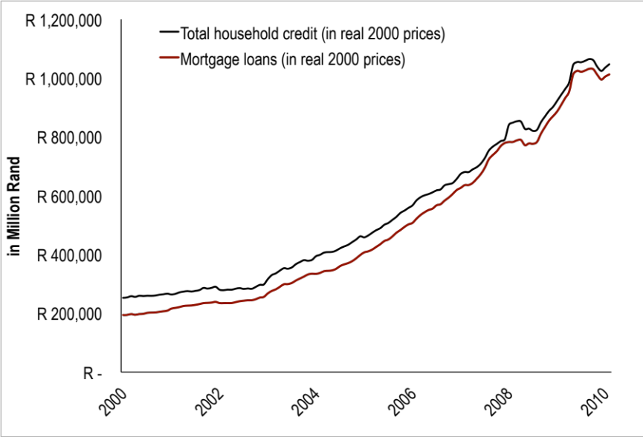
Source: Griffith-Jones with Karwoski, 2013, based on SARB, 2013.
In Mauritius, almost one third of private sector credit flows to households, equalling 20% of GDP by late 2012. The majority of household borrowing is mortgage finance (60% of total household credit) with the rest used to fund consumption (40%). Given sustained demand for residential property, housing credit has been growing close to 20% annually on average over the past 5 years (Bank of Mauritius, 2012). Simultaneously, foreign direct investment (FDI) flows into the country concentrate on real estate activities, with the bulk in tourist resorts, real estate and invest hotels schemes. The construction industry accounted for approximately half of FDI inflows in recent years (2008-2012). Mauritius’s construction boom should be monitored with caution, which has also been pointed out by the IMF Article IV Mission Consultation. Financial vulnerabilities appear to be accumulating in the industry with potential adverse impacts on balance sheets of domestic commercial banks. Even though non-performing loans as share of total credit are at reasonably low levels (they have increased from 2.1% to 3.1% between 2010 and 2012), non-performing loans in the construction industry (excluding housing loans) as share of sectorial credit are more than twice as high, rising from around 5% in 2010 to 8% in 2012. Year-on-year growth in construction credit shot up sharply during 2012, exceeding 35% by September 2013 (see figure 3).These trends seem worrying and imply the economic authorities may need to consider counter-cyclical regulation, possibly focussed in lending to construction.
Figure 3. Construction Sector Credit in Mauritius
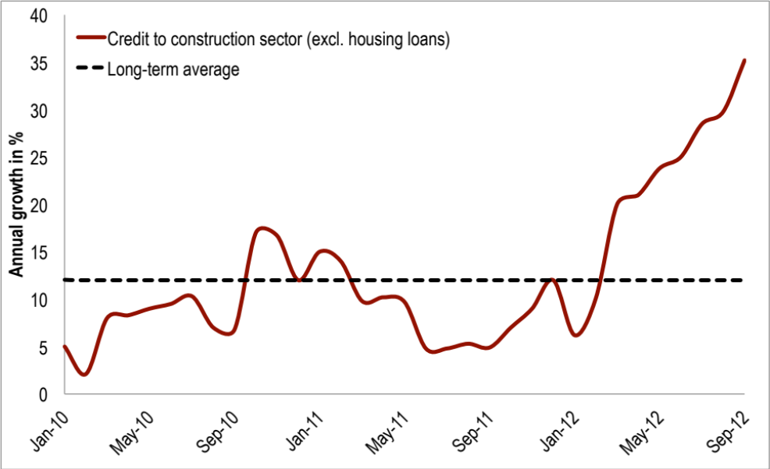
Source: Bank of Mauritius, 2012.
Limited data availability makes it difficult to measure to what extent consumption credit is on the rise in other African economies. This would seem to more urgently make the case for more disaggregated credit data as well as monitoring by regulators and policy-makers. One of the few low income SSA countries providing disaggregated domestic lending data is Mozambique (Banco de Moçambique, 2013). Private sector credit has increased significantly between 2000 and 2010 in the Southern African country from 15% to 23% of GDP (World Bank data). During this period consumer borrowing almost tripled as share of total credit, while it grew almost eightfold between 2001 and 2012 in real terms (see figure 4). Mozambique has had a strong growth performance implying a robust medium-term economic outlook according to the IMF. It seems important that financial regulators consider the need for tighter regulation of consumer credit to avoid any risks to financial stability.
Figure 4. Mozambican Consumer Credit in Real Terms and as Share of Total Private Sector Credit, 2001-2012
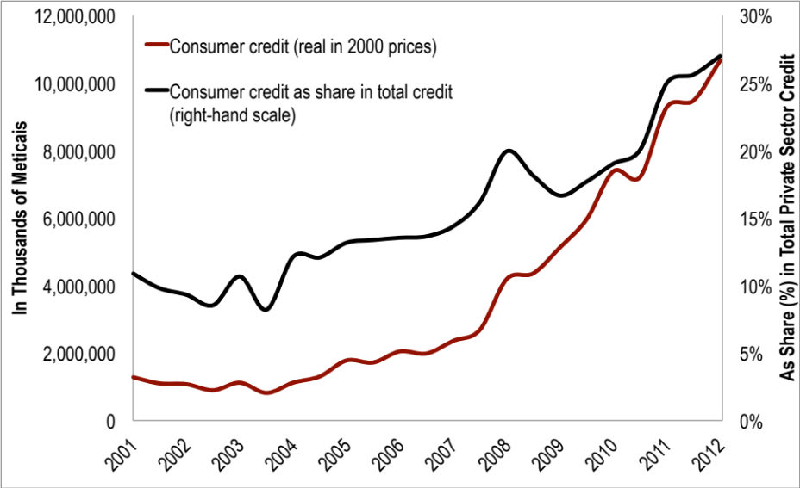
Source: Banco de Moçambique, 2013.
As regards the structure of financial systems in low income countries, a number of issues arise, including the balance between consumer and enterprise credit (partly discussed above) as well as the proportion between national and foreign banks. Here we want to focus on two others. First, should specialized lending institutions, like leasing or factoring companies, as well as low-end financial institutions, such as cooperatives, credit unions and microfinance be promoted, as suggested by Beck, Demigurc-Kunt and Singer (2011)? If the insights of imperfect and asymmetric information are central, such information tends to be local and specialized. This may provide an important theoretical and practical justification for greater use of more low-end and more decentralized institutions. Would the latter, for example, be particularly effective for the financing of SMEs, and more broadly for the so-called missing middle? For many African households such low-end financial institutions constitute the only form of financial access. In Uganda for instance only 21 percent of adults above the age of 15 have an account at a formal financial institution (Demirguc-Kunt and Klapper, 2012).
A second issue relates to a possible increased role for development banks. Since the 2007/2008 crisis, there has been increasing interest in expanding the role of national development banks (if well-functioning), to provide counter-cyclical lending when private credit falls. Also, good public banks can be valuable for incorporating environmental externalities, to give LICs the opportunity to “leap frog” by adopting low-carbon technologies, for example in renewable energy. More broadly, public development banks can be a valuable mechanism for financing particular strategies of development.
Public development banks also have the advantage that they can leverage public resources, as they fund their loans in the private capital markets, as well as co-financing with private banks and/or private investors or on-lend via private banks, as typically done for SMEs. The key issue is what are the incentives and governance arrangements that are required to make such development banks effective and efficient in LICs, as well as more broadly in developing and emerging economies? What lessons can be learned from successful banks in developed countries (e.g. at a national level, the best example perhaps being German KfW) and emerging economies (e.g. BNDES in Brazil, as well as several Asian development banks)? Most research on the experiences with development banks in Africa dates from the 1980s and 1990s and evaluations report fairly negative experiences (Brownbridge et al., 1998). Are there today well-functioning development banks in some low income countries? How can their performance be improved and how can good development banks be created? Returning to the theoretical issues, what are the specific market gaps and failures which need addressing in specific LIC contexts, and how best can government failures be minimised?
More broadly, having a more diversified financial structure for developing and emerging economies, than one just focussed mainly in private (often large) banks may have several advantages. Firstly, it may encourage competition between different types of financial institutions, which could lead to them being more efficient, for example in the spreads they charge. Secondly, a more diversified financial system, especially if not having inter-connected risks, could lead to less systemic risk and therefore contribute to financial stability. Though this seems logical, it may be useful to do careful empirical analysis, including of case studies, to see to what extent this is true. Thirdly, if different varieties of financial institutions have different strengths, having a more diverse system could make it more likely that the financial sector functions needed to help achieve inclusive growth are achieved, than if the structure of the financial sector are determined spontaneously, or dominated by one type of financial institutions, be they small or large, private or public, national or foreign.
Indeed, given that financial sectors (particularly liberalized, very lightly regulated ones, but also very repressed ones) can be very problematic for inclusive growth, the need to pursue pragmatic policies in financial sector development, as well as its regulation, and not be driven by ideology or conditioned too much by the interest of agents in the financial sector is especially important. It is important not to adopt an “either/or” attitude, but look at the best ways of building synergies amongst institutions of different type (e.g. private and public) as well as encourage best practice within them. As described above, public development banks co-finance, and increasingly lend, via private banks. Furthermore, much of their lending is done to private firms. The ability to combine private and public creatively, ideally working constructively together, is an essential feature of a financial system if it is to serve the needs of inclusive and environmentally sustainable growth. In this sense, though by no means perfect, the way the German financial sector has developed and operated, for example to successfully help fund renewable energy via public and private banks (as well as cooperative banks) and private investors acting together, provides a very good example. An interesting issue, beyond the scope of this paper, is how path dependent are the evolution of financial systems. For example, a question increasingly asked in the UK is: can the UK effectively emulate Germany in certain aspects, for example by establishing a successful public bank such as KfW, and what difficulties could it initially face given the history and structure of the UK financial system? Perhaps more relevant in the context, especially for LICs, to what extent can countries with perhaps weaker institutions and governance, create or expand good (or well-functioning) development banks that can work well with the private sector (both with private banks as well as with enterprises) to support inclusive growth. Can they successfully follow in the path of developed and emerging economies, that have done so fairly effectively, and what are the detailed lessons to learn from successes and failures?
3. Managing the capital account.
Since the revival of international capital markets in the 1960s, and the subsequent liberalization of capital controls, cross border capital flows have increased exponentially. Though most cross-border flows happen among developed economies, emerging and developing countries are increasing participants in these flows. It is widely recognized that capital flows (and particularly certain categories within them) may, under certain conditions, be a valuable supplement to domestic savings to finance investment, as well as have other benefits, like bringing technology and access to markets, in the case of foreign direct investment. However, there is growing evidence and agreement that certain capital flows can - and often do - have negative effects on growth (for a good recent review of the empirical literature, especially focussed on low income countries, see Massa, 2013).
Indeed, it can be argued (see Ffrench-Davis and Griffith-Jones, 1994, op cit. and 2011) that several pre-conditions need to be met so capital flows, especially debt based ones, contribute to produce sustained growth, that is create a virtuous cycle:
- a high proportion of inflows should go into investment ;
- the additional investment should be efficient;
- a large proportion of the increased investment should go into tradeables, to help generate the foreign currency required for servicing the debts;
- creditors and investors should be willing to provide stable and predictable capital flows on reasonable terms.
Unfortunately, it is difficult and quite rare for these conditions to be met. If they are not met, then the likelihood increases that if capital flows, especially if they are very large and easily reversible, will not contribute to sustained growth.
As discussed in the introduction, the essential problem is that capital flows, like finance in general, are pro-cyclical. Agents perceived as risky borrowers are subject to the strongest swings in the availability and costs of financing. These perceived “risky” borrowers include developing and emerging economies. Pro-cyclical capital flows are major determinants of cycles in emerging economies, and also can contribute to cycles in low income countries. Currency mismatches, to an important extent originating in capital flows, are particularly damaging for emerging and developing economies. The massive size of capital flows in proportion to the size of their economies and financial sectors is also a very problematic aspect.
An important feature of capital flows patterns, stressed for example by Ocampo (2012), is that the cyclical pattern of capital flows goes beyond volatility of short term flows, as even more problematic are medium-term cycles in availability and cost of external finance. The major problem with these medium-term cycles is their impact on key macro-economic variables, such as exchange rates, interest rates and domestic credit and asset prices (especially property prices and stock markets). Instead of disciplining macro-economic policies, as some theorists thought capital flows would do, capital flows de facto may distort macroeconomic variables and policies, and restrict the range of manoeuvre for counter-cyclical macroeconomic responses. For example, the overvaluation of exchange rates that occurs as a result of major capital inflows often leads to large increases in current account deficits, which in turn increases the likelihood of future costly crises. Overvalued exchange rates also discourage exports, with adverse impacts on growth, as exports are meant to be one of the most dynamic sectors in a market economy. Furthermore, the additional volatility of key macro-economic variables produced by volatile capital flows can have a negative effect on private investment, as they create uncertainty about future profitability.
During boom periods, capital account regulations can be justified as a way to help macro-economic authorities manage booms, by helping avoid excessive exchange rate appreciations, reducing risks of large current account deficits as well as expensive self-insurance, via accumulation of foreign exchange reserves. During crises, regulations on outflows may avoid or diminish capital flight by residents or foreigners. These regulations are widely seen to play a dual role: as a complementary macroeconomic policy tool and to help improve the structure of liabilities, by discouraging short-term, and thus more reversible, capital flows (see for the riskiness of short-term capital flows, Rodrik and Velasco, 2000).
However, as mentioned in the Introduction, an interesting recent insight on private capital flows is provided by the IMF (2011), which gives evidence that financial market volatility has spread to transactions and flows which are generally considered to be less volatile (such as foreign direct investment). One of the key ways in which the “hierarchy of volatility” of capital flows has been eroded is via the fact that foreign direct investors, as well as other actors, use derivatives markets, both to hedge their foreign exchange risk and to speculate. Especially if they do this pro-cyclically, this can imply that the net effect of foreign direct investment (though having other positive effects) can contribute to boom and bust cycles of capital flows (for more, see Griffith-Jones and Dodd, 2006 and 2007). The importance of derivatives instruments (such as non-deliverable forwards for foreign exchange), widely used in the carry trade on currencies implies new challenges for capital account regulations so they are effective, especially in emerging economies. Countries like Brazil and South Korea have de- facto started to regulate derivatives on capital flows, and it is important to evaluate their effectiveness, as well as learn lessons from them.
After the global financial crisis the Basle Committee for Banking and the Financial Stability Board led major initiatives to re-regulate finance, mainly at the national level. However, the risks associated with cross-border capital flows were left out almost entirely both from that regulatory discussion, and related analytical analysis, almost as if cross-border finance was not part of finance (Ocampo, 2013). In fact, it seems best to analyse the impacts of the domestic financial sector as well as international capital flows to and from emerging and developing countries in an integrated fashion, and to think of their regulation also in an integrated framework. This includes giving attention to regulations on transactions in foreign currencies in domestic markets, as well as regulations on capital flows proper - generally called “capital controls” but which could more adequately be called capital account regulations or management. Regulations on capital flows can be complementary with, or even be partly substituted by, domestic prudential regulations when they involve domestic financial intermediation (e.g. of currency mismatches), but not when they involve access to external capital markets by non-financial corporates. For this reason, it is important to coordinate domestic and capital account regulations nationally, and their discussion internationally.
Oversight of this issue was initially a gap in the efforts to strengthen financial regulation overall in the wake of the global financial crisis, and one which is particularly critical for emerging and developing countries, as capital account volatility plays a major role in determining boom-bust financial cycles and therefore macroeconomic as well as financial stability risks. It is very encouraging that this issue was acknowledged by the IMF in 2011-2012, which came to recognize the appropriateness of capital account regulations and recommended a set of guidelines for their implementation. The IMF rightly conceived this regulation or management of the capital account as part of broader measures on macro-prudential regulations.
The official IMF documents on this topic (IMF, 2011 and 2012) underscore the positive role that regulations on capital inflows can have but take a more critical view of regulation of outflows. In the first case, they consider that regulations are effective in changing the composition of capital inflows toward less volatile sources of finance, and thus have stability effects, but are more sceptical on their macroeconomic effects. In this regard, they consider that there is stronger evidence on the capacity of regulations to increase the room of manoeuvre for restrictive monetary policies but that there is very little evidence that they reduce the total amount of inflows or that they affect the exchange rate. In the case of regulations on outflows, the IMF considers that they are generally ineffective. The official documents have been backed by significant technical work in the institution, several of which have been favourable to the active use of these interventions (Ostry et al., 2010). The IMF documents quoted above have also argued that capital controls were effective in reducing the vulnerability of emerging economies to the North-Atlantic global financial crisis.
On the basis of this analysis, the IMF proposed some guidelines on the use of these regulations. These guidelines indicate, correctly, that these regulations should be seen as a complement and not as a substitute for macroeconomic policy. However, they visualize them as a sort of “intervention of last resort”, once countries have exhausted all other alternatives to manage booms, thus first letting exchange rates appreciate, accumulate foreign exchange reserves and adopt contractionary fiscal and monetary policies; the latter is paradoxical, as a restrictive monetary policy may actually encourage additional capital inflows. The final “institutional view” adopted in 2012 (IMF, 2012) was somewhat more favourable to the use of these regulations, but according to some analysts the IMF did not go far enough in dispelling the conception of them as interventions of last resort (Gallagher and Ocampo, 2013).
Many experts, particularly from emerging economies consider that capital account regulations should be seen as part of the normal toolkit of macroeconomic authorities and that they should be used simultaneously with other interventions to avoid the potential overheating of the domestic economy and overvaluation of the exchange rate generated by excessive capital inflows as soon as a surge becomes apparent (see, for example, the three chapters by Mohan, Nogueira Batista Jr and Zhang in Gallagher, Griffith-Jones and Ocampo, 2012). In fact, they should be conceived as part of a continuum that goes from regulations of domestic finance in domestic currency, domestic financial transactions in foreign currencies and cross-border flows, which should be regulated in a way that is consistent with the characteristic of different financial systems.
More generally, the careful analysis of experiences with capital account regulations leads to a number of conclusions by a range of observers (including Ocampo, 2012, op cit; IMF 2011, op cit; Ostry et al, 2010; Magud and Reinhart, 2007, and Kawai and Lamberte, 2010). Firstly, for capital account regulations to work, the authorities need to have good information about flows as well as administrative capacity to manage them, which includes the ability (and willingness) to close loopholes, especially by responding to the use of instruments like derivatives designed to circumvent or avoid them. Ocampo (2012) persuasively argues that permanent regulatory regimes that tighten or loosen regulations in response to external conditions may be better than building them up from scratch in times of shocks. Basic problems of data collection are key for any regulation, and would be better overcome with a permanent register. Indeed capital account regulations are difficult to implement if systematic recording of flows are not available. Secondly, regulations help increase monetary autonomy, and improve debt profiles, with the latter reducing external fragility. Some of these effects may be temporary, due to greater evasion, as time passes. Thirdly, and very important, there is agreement that capital account regulations are a complement and NOT a substitute to sound macroeconomic policies
Under Brazil’s initiative, the G-20 approved in 2011 an alternative set of guidelines to those of the IMF that have a somewhat more pragmatic view of the use of these regulations. Gallagher, Griffith-Jones and Ocampo (2012: box 2) proposed another alternative set of guidelines, which also emphasize that they are a complement and not a substitute of other macroeconomic policies, and that they should be adjusted dynamically to avoid their evasion. They underscore that there is no reason to favour price-based (taxes or unremunerated reserve requirements) over quantitative or administrative regulations (limits or prohibition of certain transactions), if the latter are more effective in practice in certain cases.
Though it is very positive that there is a great deal of agreement (including by the IMF) on the desirability of discouraging excessive inflows by capital account regulations (which will be very helpful for when the next surge of major capital inflows hit emerging and developing economies), the main policy challenge for emerging economies (and possibly also for low income countries, which have seen very large inflows in recent years, especially via bonds, see for example, Massa, op cit.) may be what to do about capital outflows in the wake of “tapering” of Quantitative Easing (QE) in the USA, especially once it starts.
Though regulations on capital outflows may be part of the policy response, they may not be enough, particularly as on the whole regulations on capital outflows are more difficult to work effectively in the moment of major pressure for outflows, even though there are some exceptions, like the Malaysian controls on outflows implemented during the East Asian crisis, which are widely seen as relatively effective. It is to be hoped that emerging and developing economies will not feel obliged to use contractionary fiscal and monetary policies as the only alternative to discourage or compensate for capital outflows. Here lies a potential large challenge for the near to medium term.
A final point on capital flow management is that measures taken by recipient emerging and developing countries may not be enough, as the sheer wall of money coming towards them is at times so large. Therefore it may be desirable to complement capital account regulation measures taken by recipient countries, with those taken by source countries, especially the US. Though the scale may be greater now, there have been previous episodes of very loose monetary policy contributing to surges in capital flows to developing and emerging economies. For this reason, the author of this paper and a co-author (D’Arista and Griffith-Jones, 1998) argued for measures to discourage large portfolio outflows from source countries, via unremunerated reserve requirements on such outflows.
In the recent period of very loose US monetary policy (including QE), following the global financial crisis, the US could have introduced measures to discourage the carry trade flows going to the rest of the world, especially to developing and emerging economies (Gallagher and Griffith-Jones, 2012).This could be done by taxing such flows (on the spot market), as well as putting higher margin requirements on derivatives that mimic spot transactions; alternatively such foreign exchange derivatives could be taxed to a level equivalent to a tax on foreign exchange spot transactions. Such measures would have not just benefitted emerging and developing economies, but would also have benefitted the US economy, as the purpose of the monetary easing was to encourage more lending and risk-taking in the US, for example higher bank lending to US SMEs. Therefore such measures to discourage outflows would have implied a WIN-WIN element, benefiting recipient emerging and developing countries as well as source developed countries. This is the reason why many observers, including Olivier Blanchard, Chief Economist at the IMF, found the case for measures in source countries persuasive. Naturally, when US monetary policy is tapered, as pointed out, the policy dilemma will be the opposite: how to avoid large outflows form emerging and developing countries.
Bibliography
Agosin, Manuel R. and Huaita, F. 2012. ‘Overreaction in capital flows to emerging markets: Booms and sudden stops,’ Journal of International Money and Finance, Elsevier, 31 (5), pp.1140-1155.
Arcand, J.L., Berkes, E. and Panissa, U. 2012. ‘Too Much Finance?’ IMF Working Paper No. 12/161. https://www.imf.org/external/pubs/ft/wp/2012/wp12161.pdf
Bagyenda, J., Brownbridge, M. and Kasekende, L. A. 2011. ‘Basel III and the global reform of financial regulation: how should Africa respond? A bank regulator’s perspective,’ New Rules for Global Finance. http://www.new-rules.org/storage/documents/g20-fsb-imf/kasakende.docx
Banco de Moçambique. 2013. Statistics, Overall Credit Statistics by Purpose, available online under: http://www.bancomoc.mz/Default_en.aspx.
Bank of Mauritius. 2013. Financial Stability Report, Port Louis, Mauritius.
Beck, T., Munzele Maimbo, S., Faye, I. and Triki, T. 2011. Financing Africa. Through the Crisis and Beyond, Washington, D.C., The International Bank for Reconstruction and Development / The World Bank.
Beck, T., Demirgüç-Kunt, A. and Singer, D. 2011. 'Is Small Beautiful? Financial Structure, Size and Access to Finance' World Bank Policy Research Working Paper 5806.

Beck, T., Buyukkarabacak, B., Rioja, F. and Valev, N. 2012. ‘Who gets the credit? And does it matter? Household vs. firm lending across countries.’ BE Journal of Macroeconomics, 12.

Beck, T. 2013. ‘Finance for development: A research Agenda’, paper prepared for ODI.
Borio, C. 2012. ‘The Financial Cycle and Macroeconomics: What have we learnt?’ BIS Working Papers No. 395, December.
Brownbridge, M., Harvey, C. and Gockel, F. 1998. Banking in Africa: the impact of financial sector reform since independence, Oxford and Trenton, NJ, James Currey and Africa World Press.
Calvo, G., Leiderman, L. and Reinhart, C. M. 1993. ‘Capital Inflows and Real Exchange Rate Appreciation in Latin America: The Role of External Factors’, IMF Staff Papers, 40(1), pp. 108-151, March.
Calvo, G. 2013. ‘Puzzling over the anatomy of crises: Liquidity and the Veil of Finance’. Paper presented at the Mayekawa Lecture at the Institute for Monetary and Economic Studies Conference, Bank of Japan, Tokyo, Japan, May 29‐30. http://www.columbia.edu/~gc2286/documents/CalvoBOJpaperMay2013REVJune282013.pdf
Cecchetti, S. G. and Kharroubi, E. July. 2012. ‘Reassessing the Impact of Finance and Growth’ BIS Working Papers No. 381: Monetary and Economic Department.
D’Arista, J. and Griffith-Jones, S. 1998. ‘The Boom of Portfolio Flows to Emerging Markets and Its Regulatory Implications’, in Montes, M. et al., (eds.), Short-Term Capital Movements and Balance of Payments Crises. Helsinki: World Institute for Development Economics Research.
de la Torre, A. and Ize, A. 2011. ‘Containing systemic risk: paradigm-based perspectives on regulatory reform’. World Bank Policy Research Working Paper 5523

Dermirguc-Kunt, A. and Klapper, L. 2012. ‘Measuring Financial Inclusion: The Global Findex Database’, World Bank Policy Research Paper.

Devlin, R., French-Davis, R. and Griffith-Jones, S. 1994. ‘Surges in Capital Flows and Development: An Overview of policy Issues’, in Ffrench-Davis, R. and Griffith-Jones, S. (eds) 1994. Coping with Capital Surges: The Return of Finance to Latin America. London: Lynne Rienner Publishers Inc, pp. 225-260.
Diaz-Alejandro, C. 1985. ‘Good-Bye Financial Repression, Hello Financial Crash’, Journal of Development Economics, 19 (1-2), pp1-24.
DTI 2010. The New Growth Path, Department of Trade and Industry, Pretoria, South Africa.
Easterly, W., Islam, R., and Stiglitz, J. 2000. ‘Shaken and Stirred, Explaining Growth Volatility’. Annual Bank Conference on Development Economics. World Bank, Washington D.C.
Ffrench-Davis, R. and Griffith-Jones, S. (eds) 1994. Coping with Capital Surges: The Return of Finance to Latin America. London: Lynne Rienner Publishers Inc.
Ffrench-Davis, R. and Griffith-Jones, S. 2011.’Taming Capital Account Shocks: Managing Booms and Busts’, in J. A. Ocampo and J. Ross (eds.), The Oxford handbook of Latin American Economics. Oxford: Oxford University Press, pp. 161 – 186.
Gallagher, K.P., Griffith-Jones, S. and Ocampo, J.A. 2012. ‘Capital Account Regulations for Stability and Development: A New Approach’ S. Pardee Center for the Study of the Long-Range Future. Issues in Brief. No. 22. http://www.bu.edu/pardee/files/2011/10/22-IIB.pdf
Gallagher, K. and Griffith-Jones, S. 2012. ‘The Need for North-South Coordination’, in Gallagher, K., Griffith-Jones, S. and Ocampo, J. A. (eds) Regulating Global Capital Flows for Long-Run Development, Boston: Boston University. pp. 103-110.
Gallagher, K. and Ocampo, J. A. 2013. ‘IMF's New View on Capital Controls’, Economic & Political Weekly, XLVIII (12), March. http://www.epw.in/commentary/imfs-new-view-capital-controls.html
Goodhart, C. A. E. 2010. ‘How, it at all, should credit rating agencies (CRAs) be regulated?’, in S. Griffith-Jones, J. A. Ocampo, and J. E. Stiglitz (eds) Time for a Visible Hand: Lessons from the 2008 World Financial Crisis. Oxford University Press: New York.
Griffith-Jones, S. 1998. Global Capital Flows: Should they be regulated? London: Macmillan.
Griffith-Jones, S., Gottschalk, R. and Cirera, X. 2003. ‘The OECD Experience with Capital Account Liberalization’, UNCTAD, Management of Capital Flows: Comparative experiences and implications for Africa. http://stephanygj.net/papers/THEOECDEXPERIENCEWITHCAPITALACCOUNTLIB2002.pdf
Griffith-Jones, S. and Dodd, R. 2006 ‘Report on Derivatives Markets: Stabilizing or Speculative Impact on Chile and a Comparison with Brazil’. Paper prepared for Economic Commission for Latin America and the Caribbean (ECLAC), May. http://stephanygj.net/papers/Derivatives_Dodd_SGJ_May2007.pdf
Griffith-Jones, S. and Dodd, R. 2007. ‘Brazil’s Derivatives Markets: Hedging, Central Bank Intervention and Regulation’. Paper prepared for ECLAC/CEPAL, December.
Griffith-Jones, S., Ocampo, J.A. and Stiglitz, J.E. 2010. Time for a Visible Hand: Lessons from the 2008 World Financial Crisis. Oxford University Press: New York.
Griffith-Jones, S. and Ocampo, J. A. 2010. ‘Building on the counter-cyclical consensus: A policy agenda’, paper prepared for the G-24 http://www.g24.org/TGM/jaosgj0810.pdf
Griffith-Jones, S. with Karwowski, E., 2013. ‘Finance and Growth in Sub-Saharan Africa: Policy and Research Challenges’, in: Working Paper, Africa Task Force Meeting, JICA and The Initiative for Policy Dialogue, Yokohama, June, pp. 139-132. http://jica-ri.jica.go.jp/publication/assets/WP_JICA_IPD_Africa_Task_Force_Meeting.pdf
Haldane, A.G. and Madouros, V. 2012. 'The Dog and the Frisbee' Bank of England. Speech given at the Federal Reserve Bank of Kansas City’s 36th economic policy symposium, “The Changing Policy Landscape”, Jackson Hole, Wyoming 31 August 2012.
IMF, 2011 ‘Managing Capital Inflows: What tools to use?’ IMF Staff Discussion Paper, Washington, D.C.: International Monetary Fund. https://www.imf.org/external/pubs/ft/sdn/2011/sdn1106.pdf

IMF, 2012. ‘Liberalizing Capital Flows and Managing Outflows’, International Monetary Fund. https://www.imf.org/external/np/pp/eng/2012/031312.pdf

Kharkar, P. 2012. ‘Countercyclical Capital Buffer’, Financial Stability Report, Bank of Uganda, June.

Kawai, M. and Lamberte, M. B. (eds) 2010. Managing Capital Flows: The Search for a Framework. Cheltenham, UK: Edward Elgar.

Keynes, J. M. 1936. The General Theory of Employment, Interest and Money. Macmillan: UK

Kindleberger, C. P. 1978. Manias, Panics, and Crashes: A History of Financial Crises, Basic Books, New York.

Larosière Commission 2009. ‘The High Level Group on Financial Supervision in the EU’, Brussels. http://ec.europa.eu/internal_market/finances/docs/de_larosiere_report_en.pdf
Levine, R. 2005. ‘Finance and growth: Theory and evidence’ in Aghion, P. and Durlauf, S. (eds), Handbook of Economic Growth, Vol. 1, London: Elsevier, pp. 865–34.
Magud, N. and Reinhart, C. M. 2007. ‘Capital Controls: An Evaluation,’ NBER Chapters, in: Capital Controls and Capital Flows in Emerging Economies: Policies, Practices and Consequences, National Bureau of Economic Research, Inc, pp. 645-674.
Marshall, A. 1923. Money, Credit, and Commerce. London: Macmillan.
Massa, I. 2013. ‘Literature survey on capital account management in low-income countries’, paper prepared for ESRC/DfID project on financial regulation in Low Income Countries. ODI.
Minsky, H. P. 1974. ‘The modelling of financial instability: An introduction,’ in Modelling and Simulation, Vol. 5, Proceedings of the Fifth Annual Pittsburgh Conference, Instruments Society of America, pp. 267–72.
Minsky, H. P. 1977. ‘A theory of Systemic Fragility’, in Altman, E. and Sametz, A. (eds) Financial Crises, New York: Wiley.
Mishkin (1996) ‘Understanding Financial Crises: A Developing Country Perspective’, NBER Working Paper Series, No. 5600, May.
Ocampo, J. A. 2012. ‘The Case For and Experience with Capital Account Regulations’, in Gallagher, K., Griffith-Jones, S. and Ocampo, J. A. (eds) Regulating Global Capital Flows for Long-Run Development, Boston: Boston University. pp. 13- 22 http://stephanygj.net/papers/RegulatingGlobalCapitalFlowsForLongRunDevelopment2012.pdf
Ocampo, J. A. 2013. ‘Reforming the International Monetary and Financial Architecture’, paper prepared for the Committe for Development Policy of ECOSOC. Forthcoming.
Ostry, J. D., Ghosh, A. R., Habermeier, K., Chamon, M., Qureshi, M. S. and Reinhardt, D. B.S. 2010. ‘Capital Inflows: The Role of Controls.’ In IMF Staff Position Note. Washington, D.C.: International Monetary Fund.

Pisani-Ferry, J. and Merler, S. 2012. ‘Sudden stops in the Eurozone’, Vox EU, 2nd April. http://www.voxeu.org/article/public-capital-flows-replacing-private-flows-eurozone-what-it-means-policy
Rajan, R. G. 2005. ‘Has financial development made the world riskier?’ Proceedings of the 2005 Jackson Hole Conference organized by the Kansas City Fed.
Reinhart, C. M. and Rogoff, K. 2011. This Time Is Different: Eight Centuries of Financial Folly, Princton: Princeton University Press.
Reisen, H. 2003. ‘Ratings since the Asian Crisis’, in Ffrench-Davis, R. and Griffith-Jones, S. (eds) From Capital Surges to Drought: Seeking Stability for Emerging Economies, NY: Palgrave Macmillan, pp. 119-138.
Rodrik, D. and Velasco, A. 2000. ‘Short-Term Capital Flows,’ NBER Working Papers 7364, National Bureau of Economic Research, Inc.
Sanusi, L. S. 2010. ‘The Nigerian Banking Industry: what went wrong and the way forward’, Convocation Lecture delivered at the Convocation Square, Bayero University, Kano, on Friday 26 February.
Soludo, C. 2004. Consolidating the Nigerian Banking Industry to Meet the Development Challenges of the 21 Century. Address delivered to the Special Meeting of the Bankers’ Committee, held on July 6, 2004. Abuja: Central Bank of Nigeria.
Stiglitz, J. 1994. Whither Socialism? Cambridge, Mass: MIT Press.
Stiglitz Commission (2009) ‘Report of the Commission of Experts of the President of the United Nations General Assembly on Reforms of the International Monetary and Financial System’, United Nations. http://www.un.org/ga/econcrisissummit/docs/FinalReport_CoE.pdf
Stiglitz, J. and Weiss, A. 1981. ‘Credit Rationing in Markets with Imperfect Information’, The American Economic Review, 71 (3), pp. 393-410
Tobin, J. 1984. ‘On the efficiency of the financial system’, Lloyds Bank Review 153, pp. 1–15.
Wampah, H. 2013. ‘What does it take to build a stable and efficient financial sector for sustained growth and structural transformation in Africa’, speech at DEGRP/ODI conference. Forthcoming in Griffith-Jones and te Velde 2014.
Warwick Commission 2009. ‘The Warwick Commission on International Financial Reform: In Praise of Unlevel Playing Fields’, Coventry: The University of Warwick. http://www2.warwick.ac.uk/research/warwickcommission/financialreform/report/uw_warcomm_intfinreform_09.pdf
World Bank, 2013. World Data Bank.

I am very grateful to François Bourguignon and Stephan Klasen for commissioning this paper and inviting me to present it as keynote speaker at the EUDN annual conference. I thank Edward Griffith-Jones for excellent research assistance.
To include some stylized facts, development banks are good at counter-cyclical lending and at providing long-term finance for private investment in infrastructure; private banks are good at providing international trade credit as well as financing the needs of foreign companies; low end institutions are good at giving credit to MSMEs, especially in specific localities.

